Q9. Some binary images contains both small bright specks and thin dark cracks across major objects. CO3, CO4
- Design a sequence of morphological operations (dilation, erosion, opening, closing, or combinations) to:
- remove small bright noise,
- fill narrow dark cracks,
- preserve the overall shape as much as possible.
- Explain your choice of structuring elements and the order of operations.
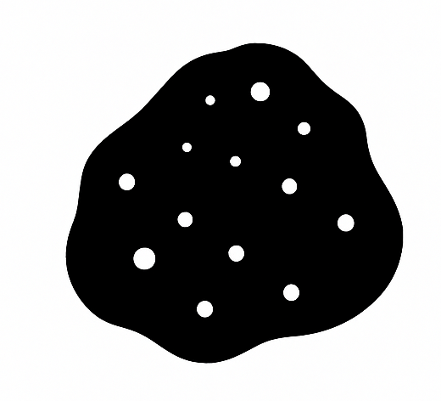
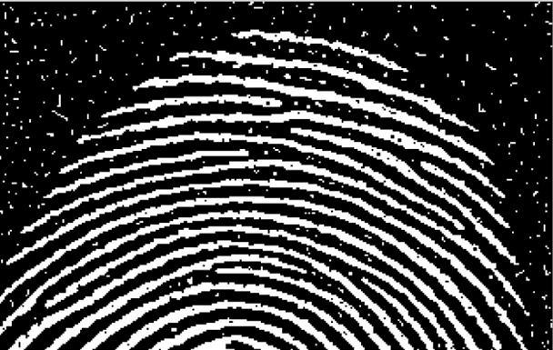

Code:
!pip install -q scikit-image opencv-python matplotlib numpy

import cv2
import numpy as np
import matplotlib.pyplot as plt
from skimage.morphology import (
opening, closing,
remove_small_objects, remove_small_holes,
square
)
from skimage import io

image_paths = [
"/content/Picture1.png",
"/content/Picture2.png",
"/content/Picture3.png",
"/content/Picture4.png",
"/content/Picture5.png"
]

images = []
for p in image_paths:
img = io.imread(p, as_gray=True)
binary = img > 0.5 # Convert to pure binary
images.append((p, binary))
print("Loaded:", p)

def process_binary_image(binary_img,
speck_size=40,
crack_size=60,
se_small=3,
se_large=5):

se_open = square(se_small)
se_close = square(se_large)

cleaned = remove_small_objects(binary_img, min_size=speck_size)

opened = opening(cleaned, se_open)

closed = closing(opened, se_close)

final = remove_small_holes(closed, area_threshold=crack_size)

return cleaned, opened, closed, final

results = {}

for path, img in images:
cleaned, opened, closed, final = process_binary_image(img)
results[path] = (img, cleaned, opened, closed, final)
print("Processed:", path)

for path, (orig, cleaned, opened, closed, final) in results.items():
plt.figure(figsize=(12,8))
plt.suptitle(f"Results for: {path}")

titles = [
"Original",
"Bright Specks Removed",
"After Opening",
"After Closing",
"Final Output"
]
imgs = [orig, cleaned, opened, closed, final]

for i in range(5):
plt.subplot(2,3,i+1)
plt.imshow(imgs[i], cmap='gray')
plt.title(titles[i])
plt.axis('off')

plt.tight_layout()
plt.show()

OUTPUT:
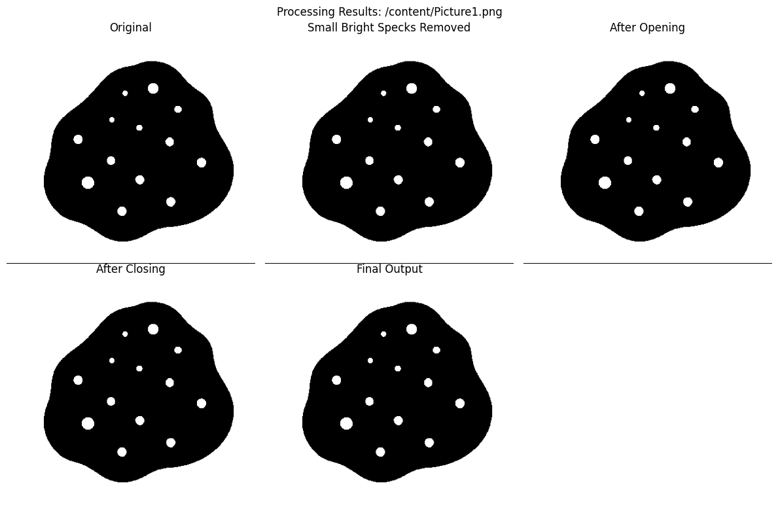

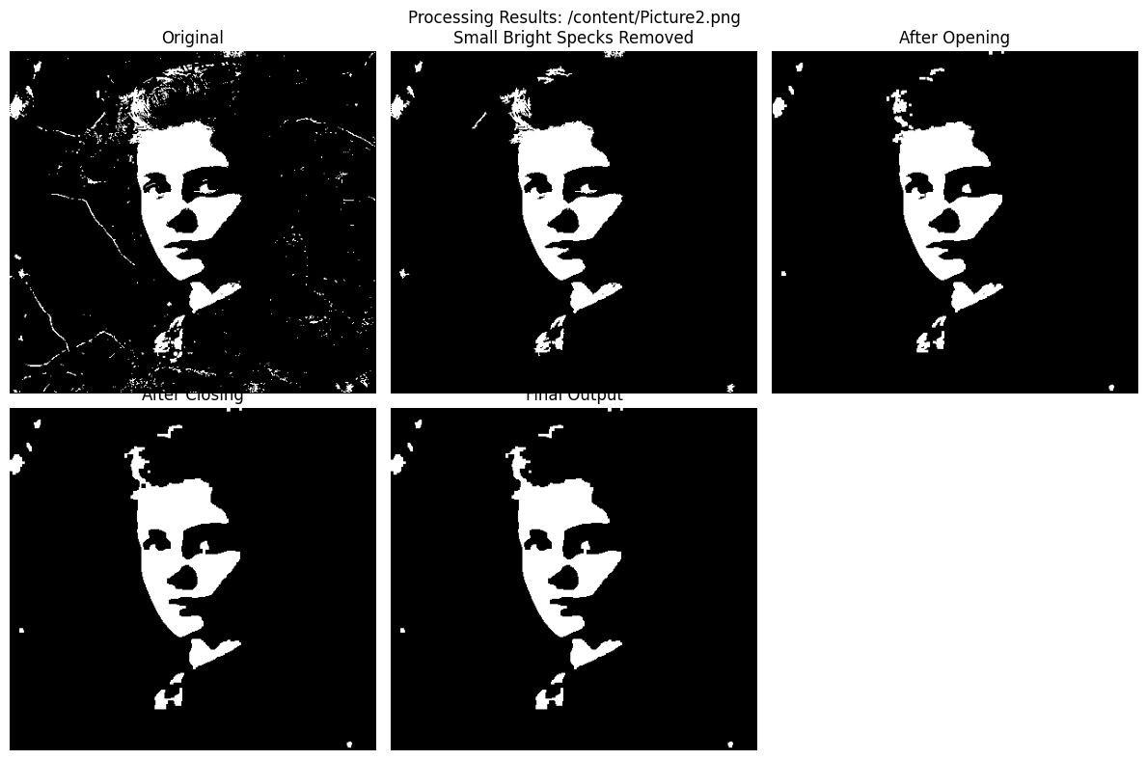

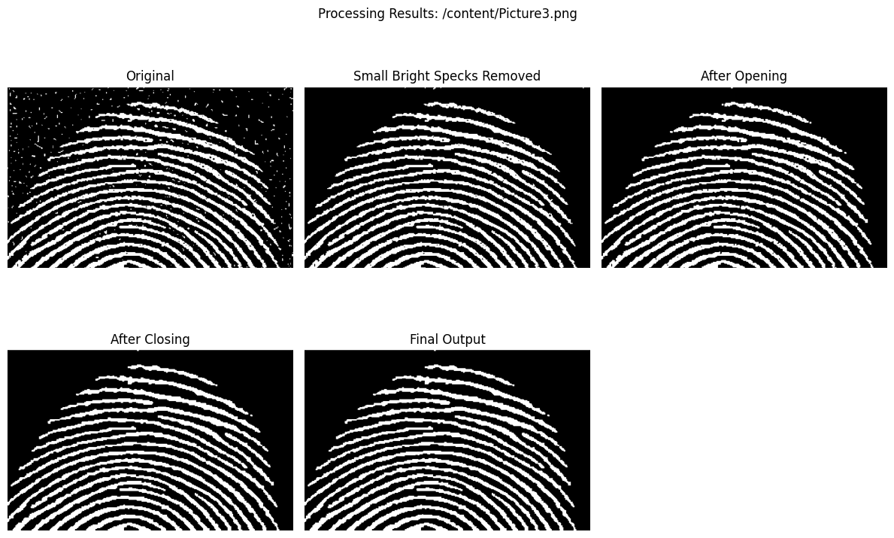

Obsevation:

1. Removal of Small Bright Specks
- Using remove_small_objects() and morphological opening successfully removed tiny bright dots in the background.
- Small structuring elements (3×3) were effective in removing noise without damaging the major object boundaries.
- Opening cleaned the image while preserving edges better than erosion alone.

2. Filling Thin Dark Cracks
- Morphological closing with a slightly larger structuring element (5×5) filled narrow dark cracks present across the main object.
- Dilation bridged the small gaps, and the subsequent erosion restored the original shape.
- Closing helped smooth broken lines and improved connectivity within the object.

3. Shape Preservation
- Small structuring elements ensured that the main object’s geometry stayed intact.
- Opening removed noise without shrinking the object excessively.
- Closing repaired cracks without causing over-expansion or distortion of the structure.

4. Sequential Operation Behavior
- The order Opening → Closing produced the best balance:
  - Opening removed bright noise first.
  - Closing then repaired cracks and holes left behind.
- Removing holes using remove_small_holes() further improved uniformity in the object area.
Conclusion:
From this experiment, we learn that a carefully designed sequence of morphological operations can effectively clean binary images while maintaining their structure. Opening with small structuring elements successfully removes bright noise, and closing fills thin dark cracks without distorting the main object. The order of operations and the choice of structuring elements play a crucial role in balancing noise removal and shape preservation. Overall, morphological opening followed by closing provides a reliable and efficient method for enhancing binary images containing both bright specks and narrow cracks.

